Setup Grandstream GXP2100 for FPL- Part one- basics

The IP will be displayed on the main screen, open the browser and type http://ipdaddress
The password is admin
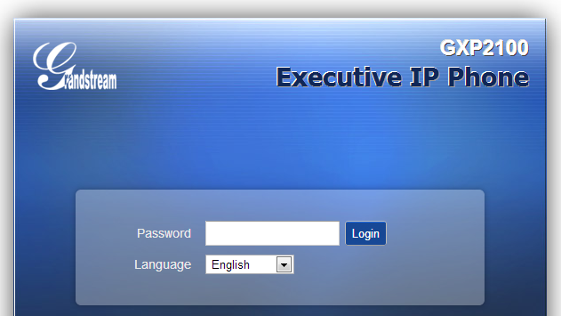

Next, you will see the status page

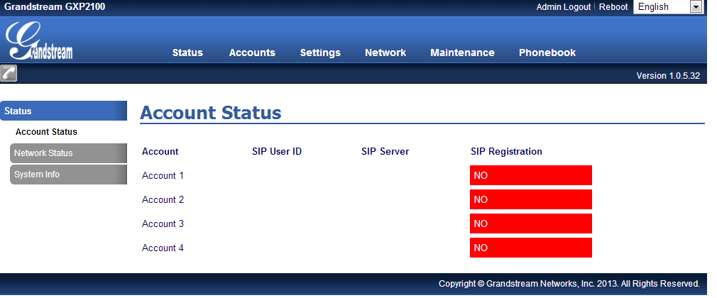
Click on Account1->General settings
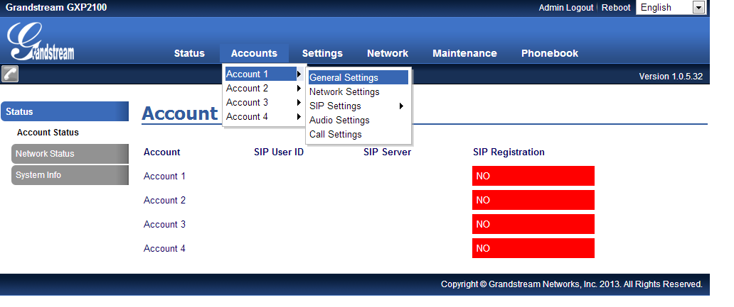
Setup your VoIP unlock credentials and click on Save and apply

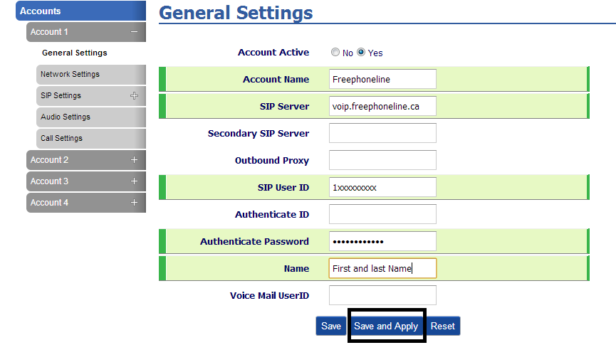

Next, click on Network settings

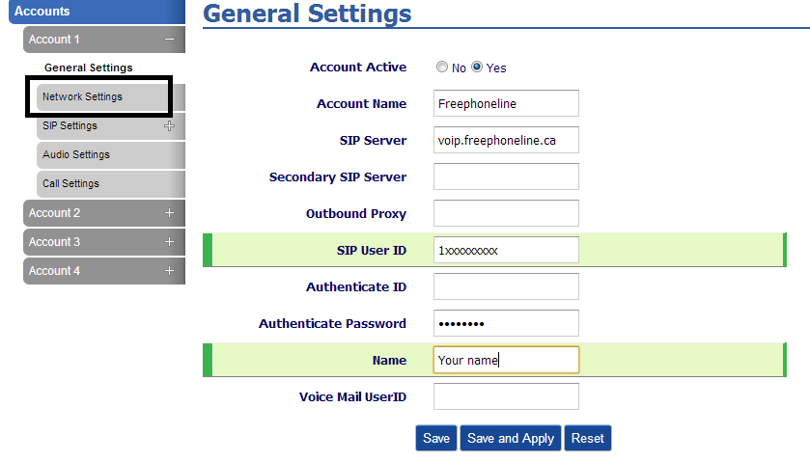

Select “Keep alive” and click on Save and apply

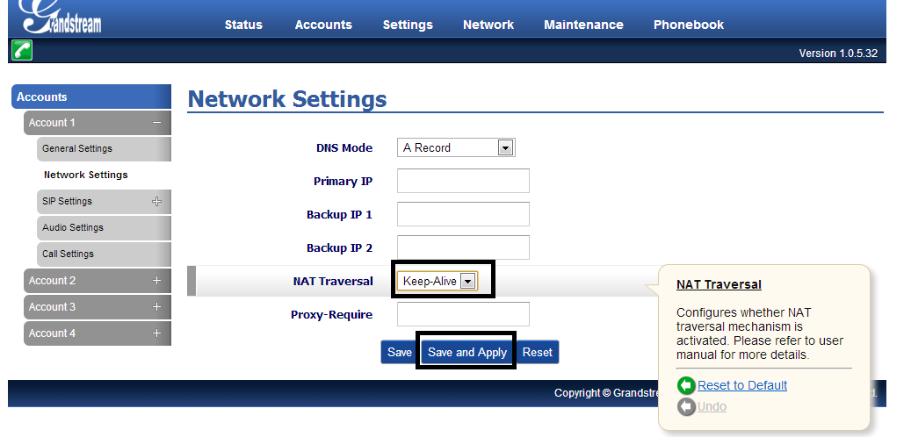

Next, click on SIP settings-
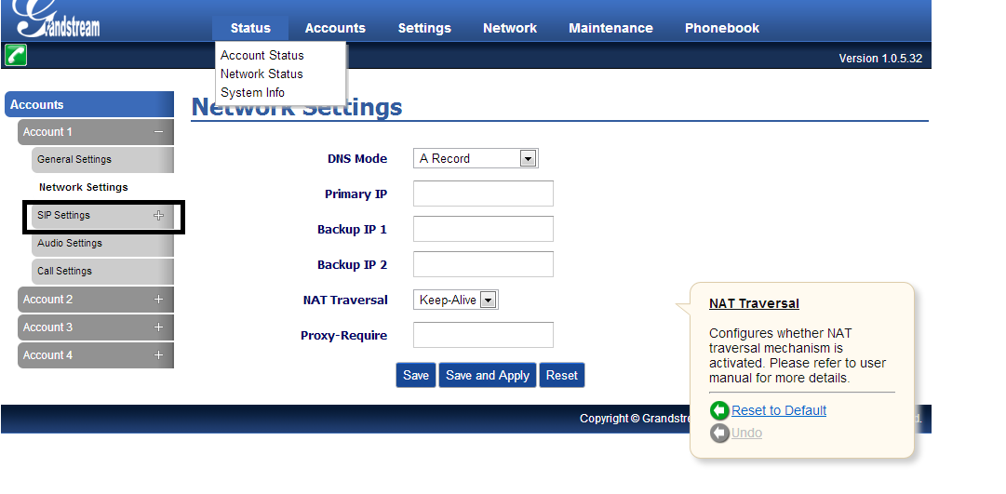
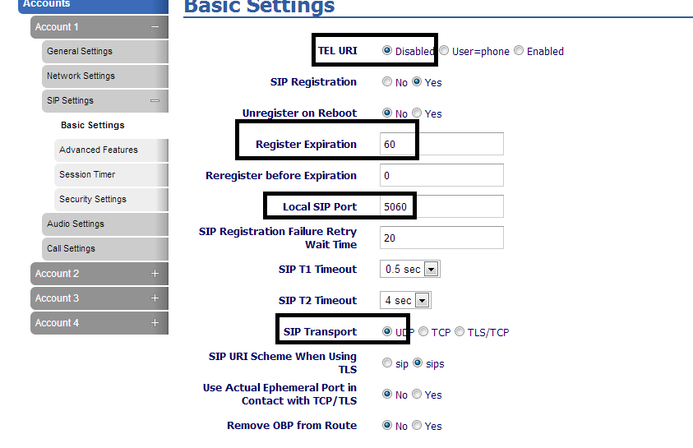
Save and apply!
Next, click on Security

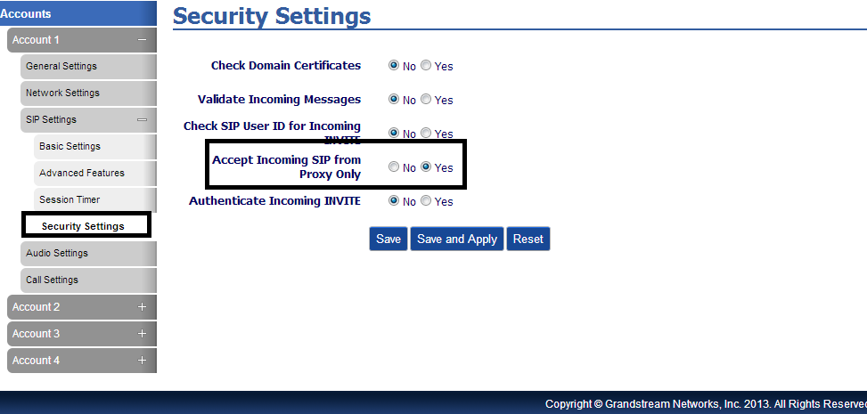
Save and apply changes
Next, go to Account1->Audio settings

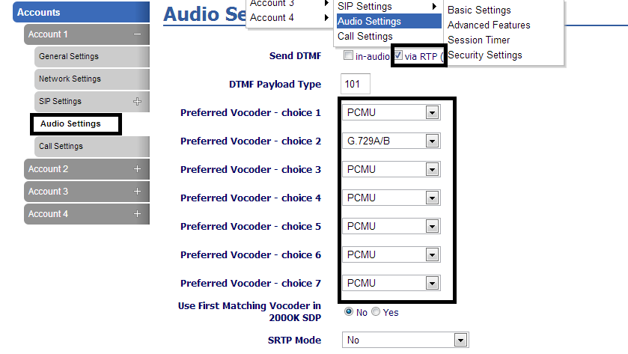

Apply all changes!
Finally, click on Account1->Status

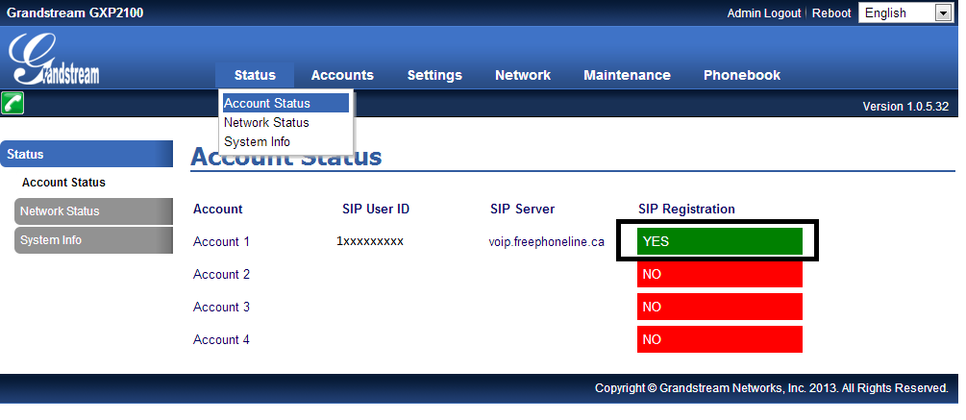

Setup is now complete and you can start making/receiving calls!

