**Linksys ATA Configuration Walk-Through**

- Plug in ATA and connect telephone into back of ATA

- Pick up the receiver, you may or may not get a dial tone

- PRESS **** 110 # on the keypad (this will give you the private IP of the ATA)

- Type the IP into your browser if you are on same private IP range

- Once the Linksys page comes up, click “Admin login” then “Switch to Advanced view”

|  |  |
| --- | --- |
| **System Tab**  Primary NTP Server: time.nist.gov  Secondary NTP Server: time.windows.com | **SIP Tab**  RTP Packet Size: 0.020  Keep alive interval: 20 |

Fig 1. SIP Parameters

Fig 2. 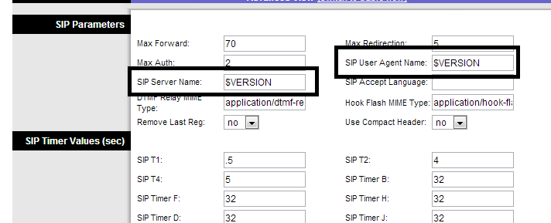RTP Parameters

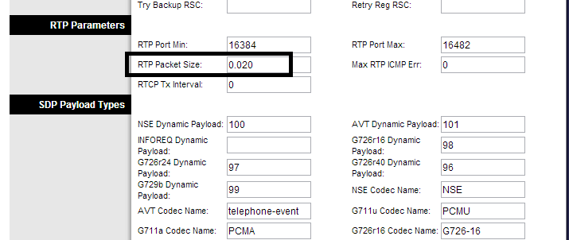

Fig 3. NAT Support Parameters

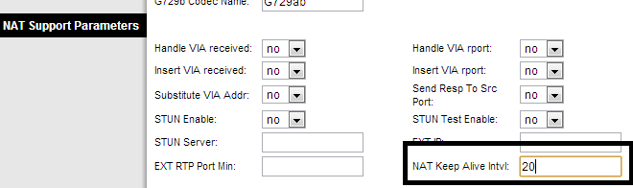

**Regional Tab**

Under “Ring and Call Waiting Tone Spec” category:

**Ring Waveform**: Sinusoid

**Ring Frequency**: 52

**Ring Voltage**: 90

Under “Time Zone” category at the bottom of the page:

**Time Zone**: GMT-5

**Daylight Savings Time Rule**: start=3/8/7/2:00;end=11/1/7/2:00;save=1

Fig 4. Ring and Call Waiting Tone Spec



Fig 5. Miscellaneous Setting



**“Line 1” Tab**

“NAT Setting” category:

**NAT Keep Alive Enabled:** Yes

**NAT Mapping Enabled:** Yes

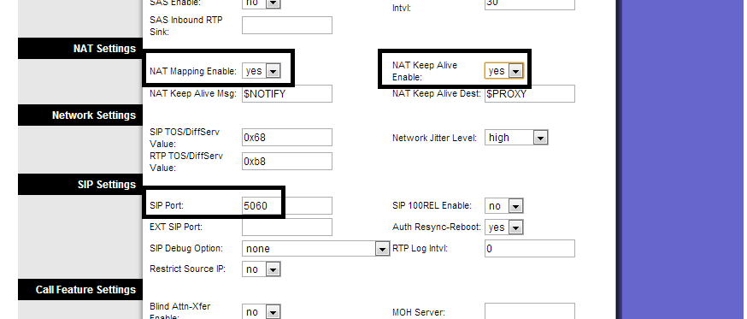

|  |  |
| --- | --- |
| “Proxy and Registration” category:  **Proxy**: voip.freephoneline.ca  **Outbound Proxy**: *<blank>*  **Registration Expires**: 3600 | “Subscriber Information” category:  **Display name:** (customer name)  **User ID:** FPL phone number including 1  **Password:** SIP Password |

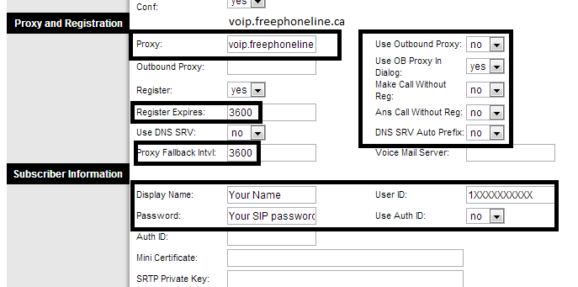

“Audio Configuration” category:

**Preferred Codec**: G711u

**Use preferred codec only**: no

“Dial Plan” category:

**Dial Plan**:

(911|[2-9]xxxxxxxxx|1xxxxxxxxxx|011xxxxxxxxxxxx.|98*|[6-7]x*xxxxxxxxxxx.)



**“Line 2” Tab**

**Line Enable**: no